Option 1: Smart Water Intake Tracker
Sensing Device: Smart Coaster
A minimalist coaster with integrated load cell sensors. Automatically detects drinking events, refills, and cup removal.

Display Device: Desktop Display Unit
Desktop unit with mechanical needle showing daily intake progress (0-100%). RGB ring provides color-coded hydration status. Reset buttons for user to restart recording everyday.
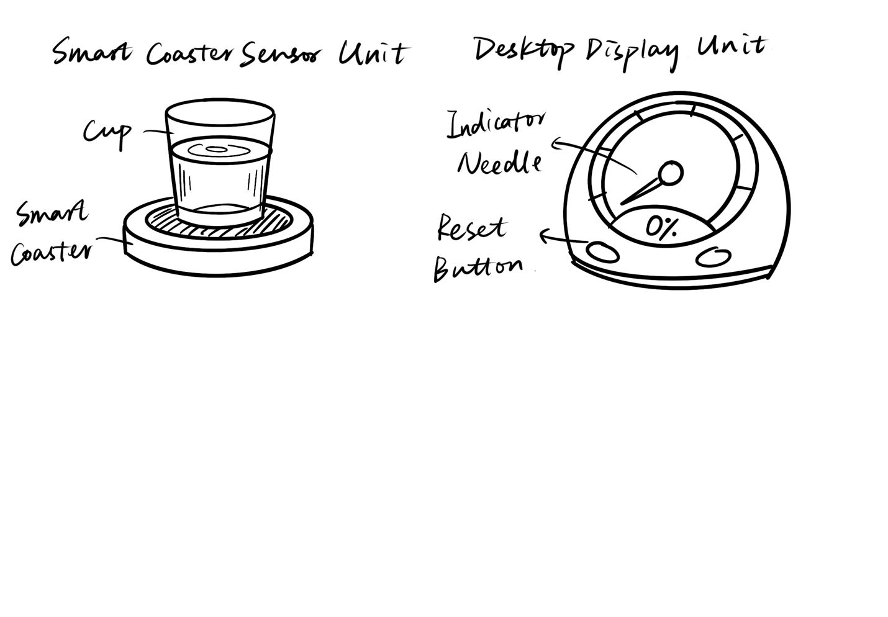

Option 2: Focus State Indicator
Sensing Device: Wearable Bio-Sensor
Wearable sensor unit for measuring GSR/EDA and optional PPG for heart rate.

Display Device: Desktop Monitor
Desktop monitor with mechanical needle showing either "current focus score" or "session duration".
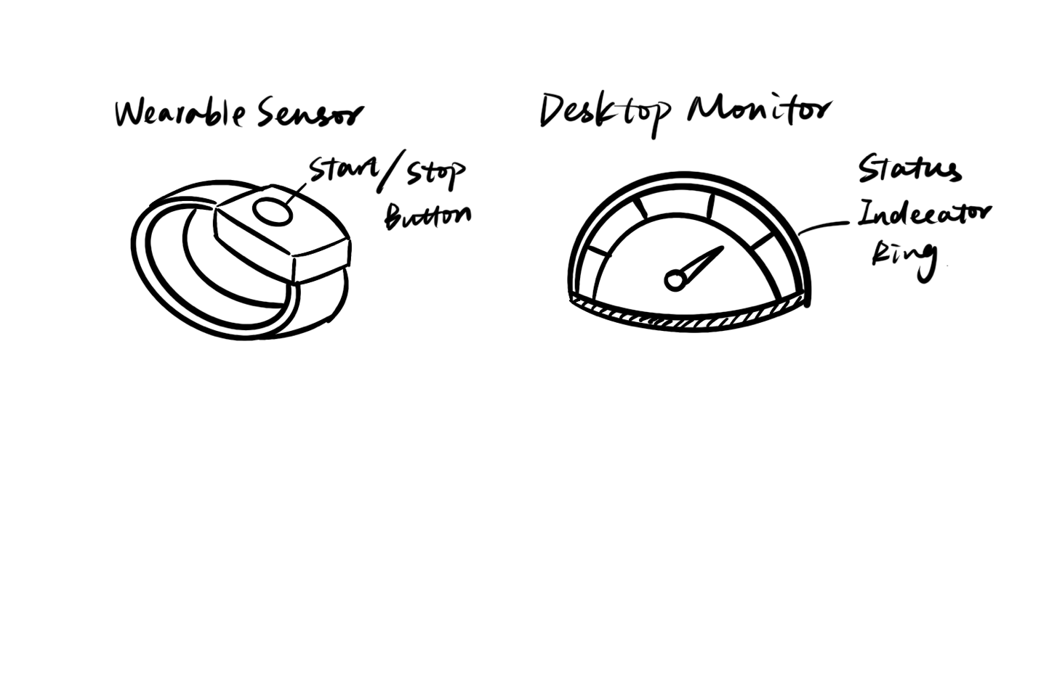

Option 3: Smart Fridge/Food Freshness Tracker
Sensing Device: Camera Unit
Compact camera module that could magnetically attaches on refrigerator. Captures food items and check freshness status. Includes physical buttons for reset.

Display Device: Freshness Gauge
External refrigerator display showing freshness status of tracked items.

